Annex 1.3

**Fixed Wireless Systems in Telecommunication Networks**

1. Introduction

This chapter deals with principles of radio rely systems (RRS). RRS have evolved during many years in the past and evolution is expected to continue in terms of both technologies and applications.

**:**Basic functions of radio relay links and a global overview about microwave links are treated here.

Radio relays systems are intended to provide connections between two or more stations with fixed locations. From the application point of view these systems can represent transport (trunking) networks, mobile backhaul networks or fixed wireless access (FWA) systems. Basically a radio relay link consists of a transmitter and a receiver (Figure 1.).



Figure 1.: radio relay link

For a basic link the following functional elements are contained: signal source, modulator, amplifiers, filters, connectors, transmission lines, antennas, transmission medium, demodulator and output. Most of these elements show specific attenuation values e.g.: (filters, transmission line, connectors, transmission medium etc.). The transmitter side of the link is described in the following chapter.

1. **Transmitter**

The transmitter produces and emits a microwave signal, which carries the information to be communicated. The transmitter generates the microwave carrier with the required power level and frequency and modulates this signal according to the input signal. Figure 2. shows a block diagram of a basic transmitter.



Figure 2.: Transmitter block diagram

1. **Transmission Line**

The transmission line carries the signal from the transmitter to the antenna and at the other side of the radio link it carries the signal from the receiving antenna to the receiver. The transmission line always represents specific attenuation values for transmitting and receiving side.

1. **Receiver**

The receiver extracts information from the microwave signal by deducing its original form. To accomplish this, the receiver must demodulate the signal to separate the information from the microwave energy.



Figure 2. Receiver block diagram

. The received signal is amplified by a low noise amplifier, in order to compensate energy loss due to signal spreading.

1. **Equipment parameters**
   1. **Transmitter**

The basic transmitter parameters for the assessment of potential interference towards other services are:

* Carrier frequency;
* Spectral characteristics (e.g. bandwidth and transmitter power density);
* Equivalent isotropically radiated power (e.i.r.p.);
* Antenna radiation pattern.

The e.i.r.p. of the transmitter is calculated taking transmitter power, feeder losses and antenna gain as the relevant 3 components. In principle the maximum e.i.r.p. value would correspond to maximum antenna gain, minimum feeder losses and maximum transmitter output power.

* 1. **Receiver**

Assessment of the effects of interference from other services towards the FS requires knowledge about the performance characteristics of the radio receiver. The following receiver parameters are important for frequency sharing:

* Noise figure;
* Noise bandwidth;
* Receiver thermal noise power density;
* received signal power levels for certain bit error rates (BER) 1 × 10−3, 1 × 10−6, 1 × 10−10 BER including post-error-correction;
* Nominal receiver input level.
  1. **Feeder/multiplexer loss range**

Due to the worldwide considerable variety of systems , different physical deployment methodologies are used. Conventional indoor systems with the radio frequency front ends in protected environment associated with a tower or rooftop mounted antenna connected by a feeder are usually deployed in lower frequency bands, full outdoor systems e with waterproofed radio frequency front ends integrated or close to the antenna in higher frequency bands.

During the last few years full outdoor systems are also used more often for lower frequency bands.

A feeder loss of 0 dB refers to full outdoor applications, a higher value for feeder loss to conventional indoor systems. Mainly for bands below 18/23 GHz, an average feeder length of about 50 m for flexible waveguide can be assumed. For some specific system deployments beside feeder and multiplexer losses in addition also losses due to multichannel combining systems have to be taken into cosideration. By doing so channel filter losses, which are taken into account by the Tx output power mask and by the Rx filter mask are excluded.

* 1. **Antenna gain range**

Full outdoor applications for PP systems without any feeder loss are usually deployed by smaller antennas. ) Reference radiation patterns can be found in Recommendations ITU‑R F.699 and ITU-R F.1245. In PMP, representative antenna types are Omni, Yagi, Dish, Sectoral. Reference radiation patterns are contained in Recommendation ITU‑R F.1336.

The following aspects should be considered carefully:

According to sharing studies not always the direction exact or close to the maximum value of antenna gain, which causes the strongest contribution for interference. Antennas with lower gain show wider beams and can therefore cause remarkable interference contributions in directions even more far away from the main beam direction. This effect may in some scenarios cause harmful interference, as FS can be either or both victim or interferer. This can be determined on a case-by-case basis for each sharing scenario taking representative parameter ranges;

, Since each type of network is characterized by a different distribution for antenna gain, the over all antenna gain distribution is representative for the whole networks population. The typical median value for antenna gain might also depend on different national market and regulatory considerations.

* 1. **e.i.r.p. range**

The e.i.r.p. range results on the range of output power, feeder loss and antenna gain as according to the equation: e.i.r.p. = (Tx output power) + (Antenna gain) – (Feeder losses). However, the actual e.i.r.p. range is not to be computed as the direct sum of the highest and lowest values of these 3 components, since the following considerations apply:

* Full outdoor applications with 0 dB value for feeder losses are usually combined with moderate output power levels.
* Regulatory limits might reduce , e.i.r.p. limits, which could be achieved by the equipment by maximum output power plus maximum gain minus minimum feeder loss (all 3 components in decibels).
* Systems with less complex modulation schema may in principle show lower transmitter back-off and consequently lower output power. However also here often a moderate lutput power has to be foreseen, since for economic reasons a design tailored on the average link budget required by the market for the relevant applications has to be taken into account.. Nevertheless for smaller channel spacing the e.i.r.p. density (dBW/MHz) usually increases.
* Systems with higher order modulation schemes require higher transmitter back-off and, higher output power. High capacity wideband systems take use of the maximum power commonly available. Due to the large transmission bandwidths the e.i.r.p. density (dBW/MHz) might not be the highest among all FS applications.
* For real networks the highest Tx output power is often not associated with the highest antenna gain.

The e.i.r.p. for different antenna directions may be calculated taking the antenna radiation pattern into account.

**f. Receiver noise figure**

The receiver noise figure includes the Rx filter losses. The value is dependent on the required link budget targeted in the system design and on cost considerations.

**g. Receiver noise power density**

The receiver noise power density is derived from the thermal noise power density and is described by the following evaution: –144 dBW/MHz + Noise figure.

Absolute Rx noise power may be derived by adding the nominal noise bandwidth factor given by

10 * log (channel spacing (in MHz)).

**h. Normalized Rx input level for 1 × 10−6 BER**

The normalized Rx input level for 10−6 BER depends on the corresponding *S*/*N* for the actual modulation scheme and on the channel bandwidth. It can be derived from the receiver noise power density by the following equation:

Normalized Rx Level (dBW/MHz) = Rx Noise power density (dBW/MHz) + *S*/*N* (dB).

Actual Rx input level is obtained by adding the nominal noise bandwidth factor given by

10 * log (channel spacing in MHz).

Information about theoretical *S*/*N* for a number of coded and uncoded modulation formats, , can be found in Recommendation ITU-R F.1101. Data on typical expected S/N figure including coding gain, are reported in the table. In other cases values in the table are derived from that Recommendation, assuming that the actual coding gain compensates at least the implementation losses.

1. **FWS in telecommunication networks**

FWS are used in telecommunication networks in various situations as shown in Fig. 4. During the 1990s, FWS infrastructure began to form major backhaul solutions for mobile phone systems and for private network systems. Since the 2000s, the demand for the mobile backhaul further increased rapidly in many parts of the world, due to the intense increase of broadband mobile service applications.

The advantageous features of FWS compared to wired systems are as follows:

* Independence from geographical features, such as mountains and archipelagos;
* Short- system implementation time at low cost;
* Robustness against disasters and other incidental disruption.

These features of FWS have a strong impact on the rapid and large-scale network deployments enabling quick acquisitions of mobile phone subscribers for broadband services, which has been a key economic factor in the rapid growth of the market for FWS.



Figure 4. FWS use in telecommunication networks

1. **Transport (trunking) networks**

Traditional transport networks for long-haul or for inter-exchange in telecommunications infrastructure networks typically operate in frequency bands below 15 GHz. Due to the increase in traffic demand, many service providers deployefibre optic networks rather than new very-high-capacity radio‑relay networks. Although this holds true mainly in highly populated areas, where major towns are connected by highways facilitating the fibre optic deployment alongside, in contrast to that there are still areas, where it is difficult to deploy fibre optic networks due to geographical or economic reasons or where it is economically convenient to upgrade already existing long-haul trunk infrastructure by new spectral efficient equipment. In such cases, radio-relay-networks still continue to play an important role.

Quadrature Amplitude Modulation (QAM) modulation techniques are currently adopted for transport networks according to the FWS parameters listed in Recommendation ITU‑R F.758. Lower modulation level techniques such as 16 QAM or QPSK enable FWS to be applied for transmission links with a longer hop distance, which may be required for special areas like offshore islands.

**8. Mobile backhaul networks**

Mobile backhaul networks are undergoing a transformation process due to increasing data volumes by mobile terminals. This increase is mainly the result of the introduction of “smart phones” and in many cases the introduction of fixed prices with no upper limit on the amount of data communications traffic. Report ITU-R M.2243 refers to UMTS Forum Report 44 in which a worldwide mobile traffic of more than 127 Exabytes (EB) for  2020 is forecasted. This represents a 33 times increase compared to 2010. According to this Report Asia will represent 34.3% of total worldwide mobile traffic, while Europe and the Americas (including North, Central and South America) 22% and 21.4%, respectively. In order to support the remarkable data increase per mobile terminal, it has become necessary to reduce the cell radius of mobile base stations (BS). The reduction of cell radius has resulted in developments for further reduction of costs and physical size of BS and associated backhaul equipment.

The survey conducted by the ECO of CEPT/ECC on current use of FWS in Europe and reported in ECC Report 173 provides evidence for increasing deployment of very high capacity systems for mobile backhaul. These very high capacity links can provide a viable alternative to deploying fibre optics, especially in rural areas, and equally in high-dense urban areas, in which it would not be physically or economically feasible to deploy fibre optic systems for example by digging up roads to lay down fibre.

As a consequence of these trends an increased use of new higher frequency bands by FWS for shorter distances is resulting, since higher frequencies are also associated with wider bandwidths, higher capacity and smaller antenna dimensions. For example, the bands from 42 to 52 GHz are newly employed in addition to existing frequency bands below 40 GHz. There is also a strong focus on the 60 GHz (57-64 GHz) and the 70 to 80 GHz (71-76 GHz and 81-86 GHz) bands.

For mobile communication access networks downlink traffic from BS towards subscribers is generally higher than uplink traffic. Therefore, asymmetric frequency assignment plans are considered in some mobile applications. This point may affect future frequency assignment plans for FWS providing mobile backhaul networks in various frequency bands.

In order to achieve high bitrates in the magnitude of one gigabit per second for mobile backhaul, among others the following technologies for FWS have been introduced within the commonly available frequency bands between 6 to 40 GHz: very high order modulation, adaptive modulation, radio-link aggregation, polarization multiplexing and line-of-sight MIMO. It is also reported that applying these technologies to the higher bands from the recently available 42 GHz to those in the 50-55 GHz range or to the even wider channels in the 70/80 GHz frequency bands backhaul capacities approaching 10 Gbit/s and 40 Gbit/s. could be achieved.

ITU-R has started studies to develop a new Report to address the use of the fixed service to support the different hierarchical levels of the transport network of IMT systems (i.e. IMT-2000 and IMT‑Advanced), taking into account the above mentioned new technologies.

**9. Fixed wireless access (FWA) systems**

FWA systems are intended to provide connections between a network station (network access point) and terminal stations (end-user terminations). Both locations are fixed. FWA systems are categorized either P-P or P-MP according to their topology as depicted in Fig. 4. In P-MP systems, a single central station can provide coverage to a number of terminal stations although requiring higher gain antenna and/or higher transmission power of terminal stations compared to P-P systems in order to achieve the same hop distance. Since demand for data and video telecommunications with much higher data rate than for voice service is increasing, , FWA systems are also adopting broadband services. The demand for broadband telecommunications is currently rising all over the world and FWA systems are advantageous compared to wired systems for providing broadband telecommunications economically and quickly in regions, in wich the telecommunications infrastructure is not well developed. FWA systems operating in higher bands above 17 GHz with wider bandwidth available may be able to provide broadband data rates similar to fibre to the home (FTTH) service on account. .

The following further applications may be within the frame of FWA as specified in Recommendation ITU‑R F.1399, or can be considered as extensions of FWA. These applications in the same or appropriate close-by bands might be realised by the relevant mobile backhaul technology or by similar equipment :

* Bridging two local/private area networks between separate buildings.
* P-MP backhaul.
* Links for machine-to-machine type communication.

Home networks.

**10. Disaster relief and physical diversity links**

Short installation time is one of the important advantages of wireless systems. . Another one is the physical-diversity system configuration with pre-deployed independent or backed-up power sources, which supplements or substitute fibre networks. These features will enable recovery, if existing fibre networks are damaged in disasters, such as earthquakes and tsunamis. Future developments for disaster recovery links aim at capacity anddata rate expansion, at compatibility with latest network interfaces and at a reduction of power consumption, since these disaster recovery links should continue uninterrupted operation by portable batteries or portable generators until power supplies are recovered.

**11.Electronic news gathering**

Electronic news gathering (ENG) is another application of FWS for temporary use.. System characteristics and user requirements for ENG and other broadcasting auxiliary services (BAS) in the fixed service are specified in Recommendation ITU-R F.1777. Report ITU-R BT.2069 provides information on the current status of ENG. ENG enables the relay of a live TV broadcast from various places without  wired network installation. Existing wireless ENG links transmit digital high-definition (HD) videos using video signal compression, because the data rate of the wireless link is below 100 Mbit/s in contrast to the considerably higher data rate of 1.485 Gbit/s for the serial digital interface (HD-SDI) signal of the digital HD video standard for high definition. . The unavoidable significant latency time due to the video signal compression is disadvantageous for live TV program production , especially if the moving picture experts group 2 (MPEG-2) standard is used for video signal compression. Recent progress in video compression technologies, such as H.264/MPEG4, which is one of the most commonly used video compression formats, reduces the latency time due to video compression below 30 msec. There is also still a strong need for wireless links to transmit HD-SDI signals without compression, because video compression and decompression deteriorates the video quality. The 60, 70 and 80 GHz bands can support transmission of uncompressed HD-SDI signals and TV programs have already been transmitted using these bands.

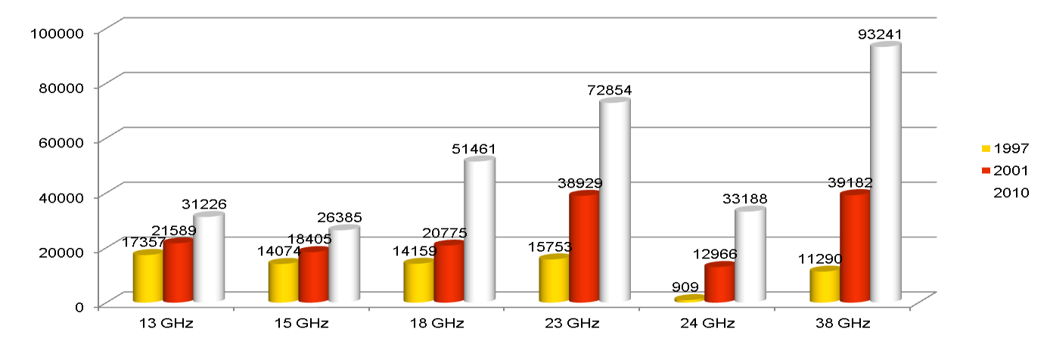

Figure 5. Trends of links for each band in Euro**pe**

**12. New links topology**

In the various scenarios under study for a suitable solution for small cells it has to be considered, that for such a design in urban areas PP links are deeply entering the streets canyons, even if they are still under LOS conditions, so that the issue of reflection on building and other urban clutters cannot be disregarded. This may also require further study in the propagation prediction methods in particular for higher frequency bands [HANSRYD J. and EDSTAM J. (January 2011)].

**13.Microwave network topology evolution**

Conventional microwave networks are based on daisy chain and tree backhaul topologies, as shown in the top portion of the following figure, even though the benefits of ring topologies were well known:

Since traffic within a ring can be sent in two directions around a ring, the load capacity of the ring is effectively doubled under the assumption that no failure appears.

Rings offer a reduction in protection CAPEX, since each ring site has two paths around a ring. This eliminates the need for fully protected aggregation sites, which offer only one path towards the core network.

The main reason for the reluctance to deploy ring architectures in the past was bandwidth inefficiency associated with SONET/SDH protocols. Specific protection bandwidth had to be reserved. This bandwidth could not be used for additional capacity, if no failures in the network appeared. . This wasn’t a limitation in higher capacity fibre networks, but it was a severe limitation when trying to leverage scarce microwave spectrum. Hence, rings never emerged as a widely deployed microwave network topology.

A new Ethernet based networking protocol was required to replace SONET/SDH, to support the gold standard of 50 ms protection, and with the ability to carry IP services in an optimal way. The ITU-T G.8032v2 standard has evolved as the suitable protocol for this purpose for packet microwave networks based on an underlying Ethernet technology.



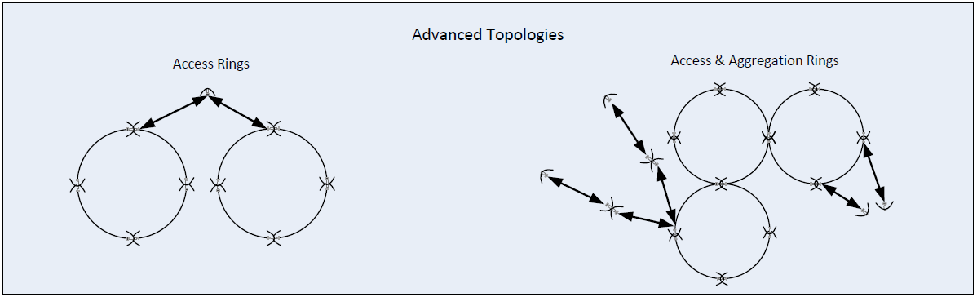

Figure 6. Network topologies

Since ITU-T G.8032v2 is based on Ethernet, it can be used on any Ethernet media like  copper, fiber, or packet microwave. Ethernet channel bonding techniques such as multichannel can also be used to scale microwave capacity.

**14.Passive and RF repeaters**

Most FWS in bands above 3 GHz use parabolic antennas, including front feed antenna, offset feed antennas, Cassegrain antennas, and Gregorian antenna. However, some FS in bands below 3 GHz in particular 1.4 GHz band uses mix of flat panel, Yagi and parabolic antennas due to low profile and other installation/infrastructure considerations for these applications.

The gain of a parabolic dish antenna G is given as follows:

$G [dBi]=10log⁡(\frac{4πA}{λ^{2}}e_{A})=10log⁡(\frac{π^{2}D^{2}}{λ^{2}}e_{A})$

*A* is the area of the antenna aperture, *d* is the diameter of the parabolic reflector, λ is the wavelength of the radio wave, and *eA* is a dimensionless parameter between 0 and 1 called the aperture efficiency. The aperture efficiency of typical parabolic antennas is in the range 0.55 to 0.70. Figure 7 shows the antenna gain calculated by using this equation. The diameter of the parabolic antenna for FWS can be selected by considering the link distance, carrier frequency, output power, receiver sensitivity and availability of the link.

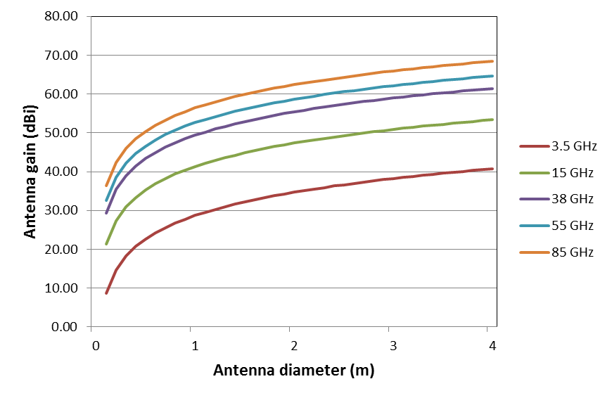

Figure 7. Relationship between parabolic antenna gain and antenna diameter ( $e_{A}$ = 0.55)

The use of antennas other than parabolic antennas, such as slot or patch arrays, has been investigated in order to reduce antenna cost and/or to improve the antenna characteristics for specific applications in order to avoid unpleasant views in sensitive areas.



Figure 8. Passive repeater

A typical passive repeater configuration implemented by the installation of a flat “billboard” is demonstrated in Figure 8.

**AE**

**AE –** The effective area of the antenna

**GR –** The gain of the A antenna

For the back-to-back antenna-case, path losses are calculated separately for each hop. Interference can occur via the direct paths and the reflector. The gain of the reflector is given by:

**G $=21.45+20\log\left(f\right)+ 10 log [ A\cos{(}\frac{γ}{2} )] dB$**

f frequency in GHz

A actual area of the reflector in m2; and

γ angle between the incident and reflected beams

In many situations passive repeaters can offer practical and economic solutions. Nevertheless, their application is typically constrained by path geometry and terrain considerations. In addition to the need to obtain adequate system gain care has to be taken to ensure, that the direct path signal (in this case an unwanted signal) remains well below the system threshold also during periods of abnormal propagation.

For the system planner, passive repeaters are sometimes a useful option in cases, where the direct propagation path is obstructed and another existing site can be used to direct sufficient signal energy around the obstacle to satisfy the overall system gain requirement. The most common types of passive repeaters include “back-to-back” antennas and “billboard” reflectors.

A typical back-to-back configuration is demonstrated in Figure 9.

Station C

Station A

Passive Repeater  
 D E

Station I

Border

Figure 9. Back-to-back passive repeaters

Victim: link ADEC

Interferer: station I

The total path losses between site A and site C are calculated using the following equations:

atot = aTx - GTx + apropID - GD + aantID + aDE - GE +apropEC - GC +aantEC + aRx + MD + NFD + ATPC

where

apropID [dB] propagation attenuation between antennas I and D that can be calculated on the  
 basis of the result of calculation covered in Annex 10. In conformity with the type of path.

apropEC [dB] propagation attenuation between antennas E and C that can be calculated on the  
 basis of the result of calculation covered in Annex 10. In conformity with the  
 type of path.

aantID [dB] attenuation which is a function of antennas I and D radiation patterns and   
 polarisation discrimination.

aantEC[dB] attenuation which is a function of antennas E and C radiation patterns and   
 polarisation discrimination.

aDE [dB] attenuation between antennas D and E (wave guide attenuation).

**References:**

* Radio Regulations (Edition 2012)
* HCM Agreement
* ITU-R Recommendations (F and SF)
* ITU-R Reports (F)
* ECC Recommendations
* ECC Reports
* ERC REPORT 25 (2015)
* ERC Report 173
* CEPT Report 19